**VISVESVARAYA TECHNOLOGICAL UNIVERSITY**

**“JnanaSangama”, Belgaum -590014, Karnataka.**



**LAB RECORD**

**Computer Network Lab (23CS5PCCON)**

***Submitted by***

**Eashan Jain V (1BM23CS098)**

***in partial fulfillment for the award of the degree of***

**BACHELOR OF ENGINEERING**

***in***

**COMPUTER SCIENCE AND ENGINEERING**



**B.M.S. COLLEGE OF ENGINEERING**

**(Autonomous Institution under VTU)**

**BENGALURU-560019**

**Academic Year 2024-25 (odd)**

B.M.S. College of Engineering

**Bull Temple Road, Bangalore 560019**

(Affiliated To Visvesvaraya Technological University, Belgaum)

**Department of Computer Science and Engineering**



**CERTIFICATE**

This is to certify that the Lab work entitled “ Computer Network (23CS5PCCON)” carried out by **Eashan Jain V(1BM23CS098),** who is bonafide student of **B.M.S. College of Engineering.** It is in partial fulfilment for the award of **Bachelor of Engineering in Computer Science and Engineering** of the Visvesvaraya Technological University, Belgaum. The Lab report has been approved as it satisfies the academic requirements of the above-mentioned subject and the work prescribed for the said degree.

Dr. Kavitha Sooda Professor & HOD

Department of CSE, BMSCE

Sarala D V Assistant Professor

Department of CSE, BMSCE

**Index**

|  |  |  |  |
| --- | --- | --- | --- |
| **Sl.**  **No.** | **Date** | **Experiment Title** | **Page No.** |
| 1 | 19/08/2025 | Create a topology and simulate sending a simple PDU from source to destination using hub and switch as connecting devices and demonstrate ping message. | 1 |
| 2 | 03/09/2025 | Configure IP address to routers in packet tracer. Explore the following messages: ping responses, destination unreachable, request timed out, reply | 4 |
| 3 | 10/09/2025 | Configure default route, static route to the Router | 8 |
| 4 | 9/09/2025 | Configure DHCP within a LAN and outside LAN. | 11 |
| 5 | 23/10/2025 | Configure RIP routing Protocol in Routers | 14 |
| 6 | 14/10/2025 | Configure OSPF routing protocol | 17 |
| 7 | 11/11/2025 | Demonstrate the TTL/ Life of a Packet | 21 |
| 8 | 9/9/2025 | Configure Web Server, DNS within a LAN. | 23 |
| 9 | 18/11/2025 | To construct simple LAN and understand the concept and operation of Address Resolution Protocol (ARP) | 25 |
| 10 | 18/11/2025 | To understand the operation of TELNET by accessing the router in server room from a PC in IT office. | 28 |
| 11 | 14/10/2025 | To construct a VLAN and make the PC’s communicate among a VLAN | 31 |
| 12 | 11/11/2025 | To construct a WLAN and make the nodes communicate wirelessly | 34 |
| 13 | 28/10/2025 | Write a program for error detecting code using CRC-CCITT (16-bits). | 37 |
| 14 | 28/10/2025 | Write a program for congestion control using Leaky bucket algorithm. | 42 |
| 15 | 17/11/2025 | Using TCP/IP sockets, write a client-server program to make client sending the file name and the server to send back the contents of the requested file if present. | 45 |
| 16 | 17/11/2025 | Using UDP sockets, write a client-server program to make client sending the file name and the server to send back the contents of the requested file if present. | 47 |

**Github Link : github.com/eashanjn/CN**

**Program 1**

Aim : Create a topology and simulate sending a simple PDU from source to destination using hub and switch as connecting devices and demonstrate ping message.

Observation:

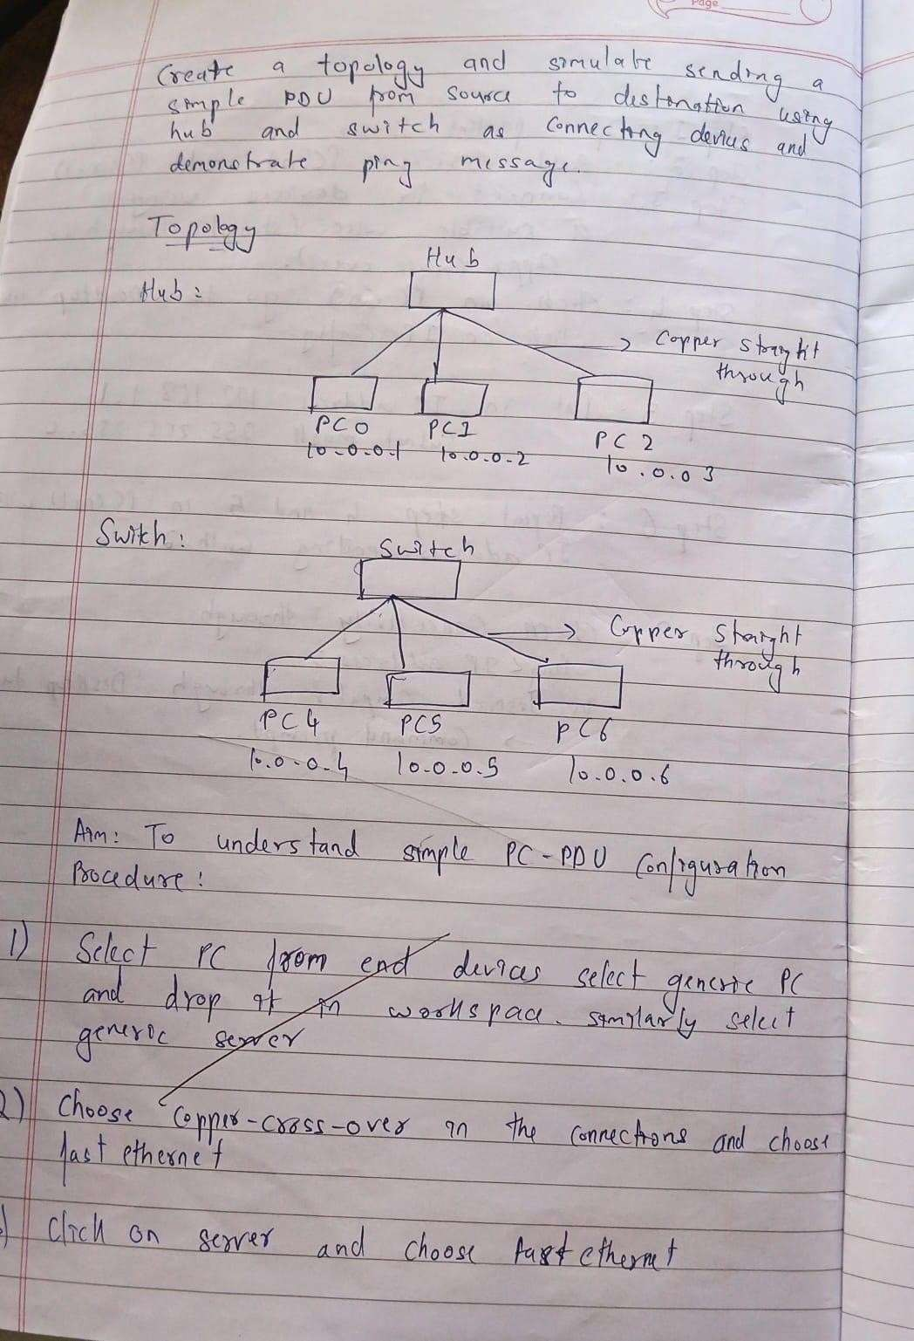

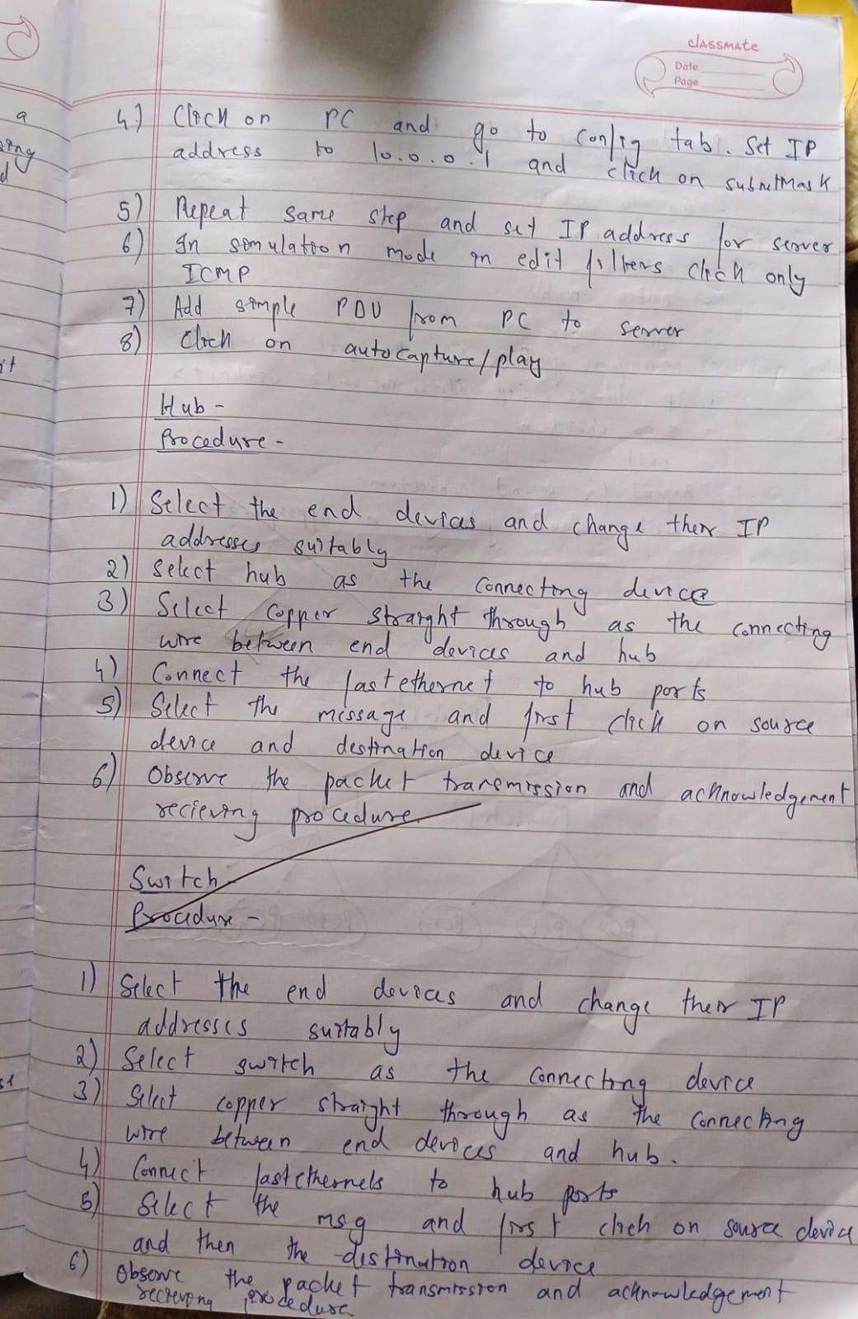

Output:

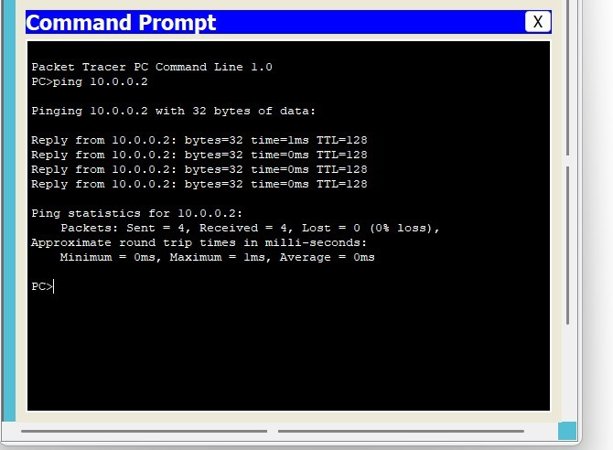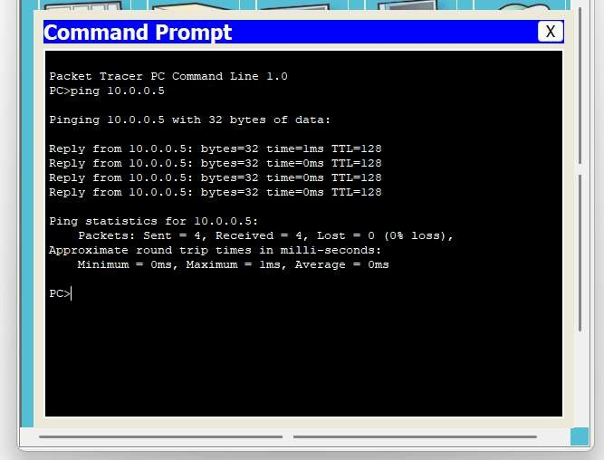

**Program 2**

Aim : Configure IP address to routers in packet tracer. Explore the following messages: ping responses, destination unreachable, request timed out, reply

Observation:

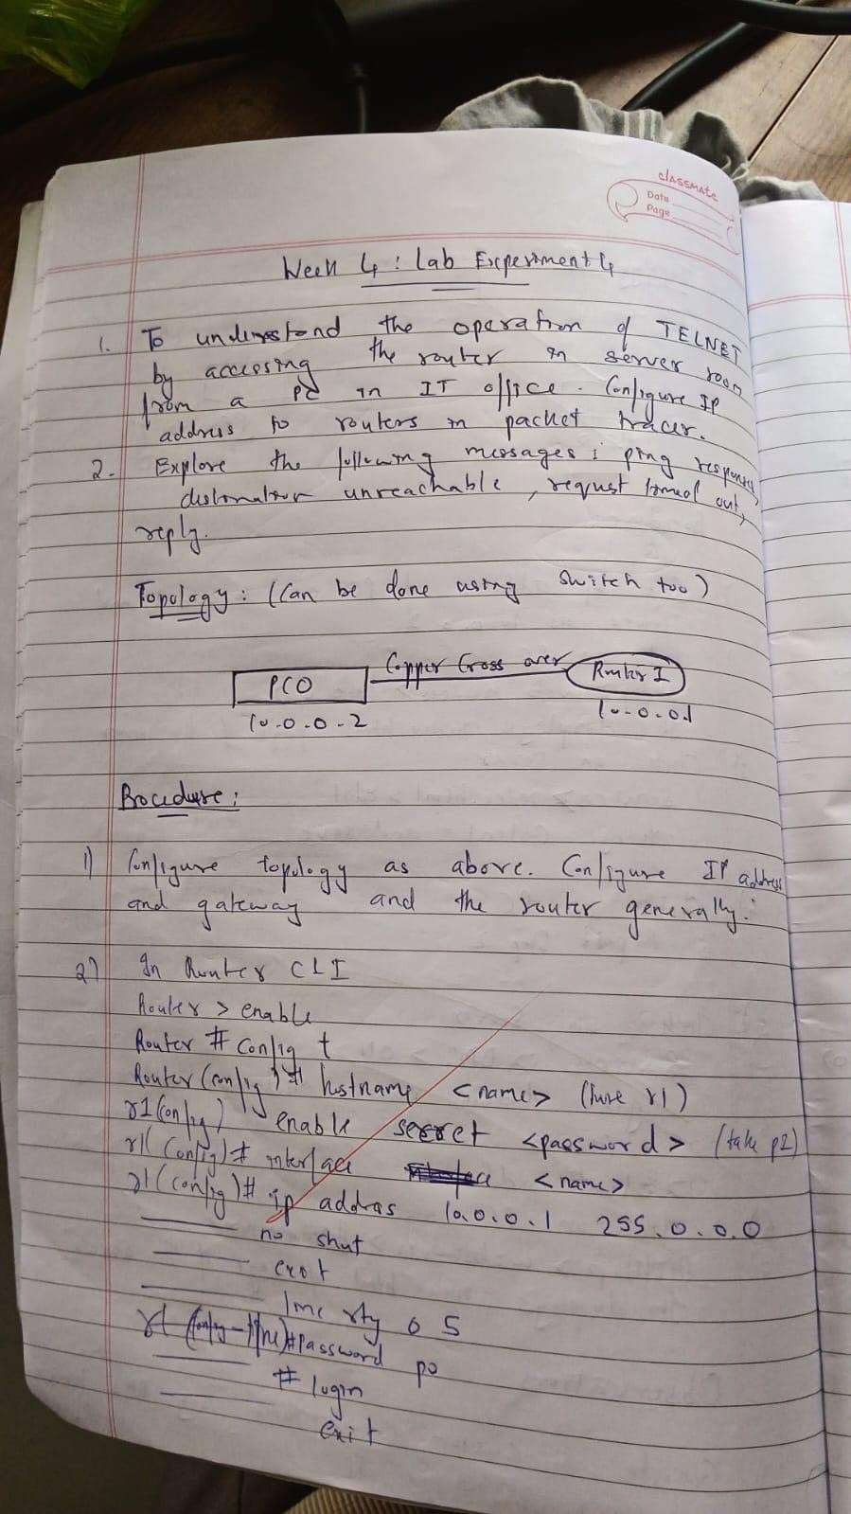

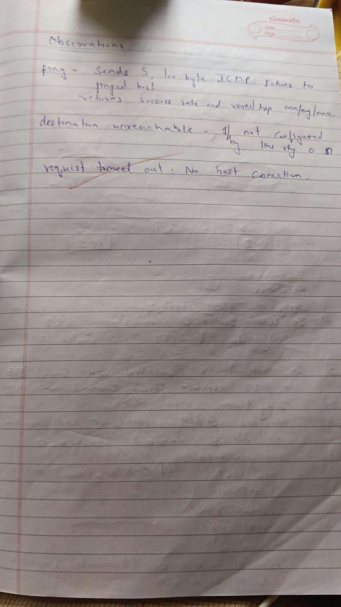

Output:

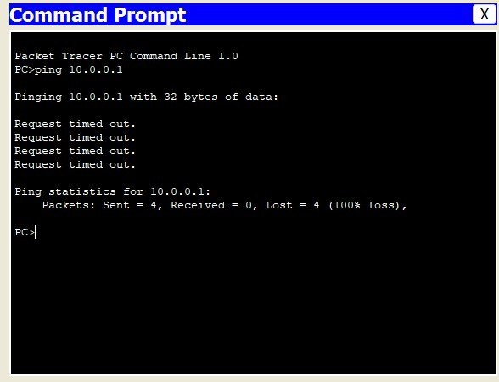

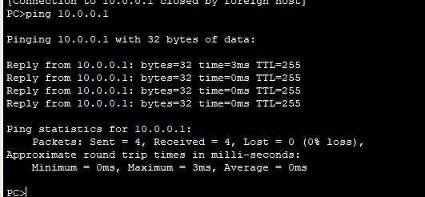

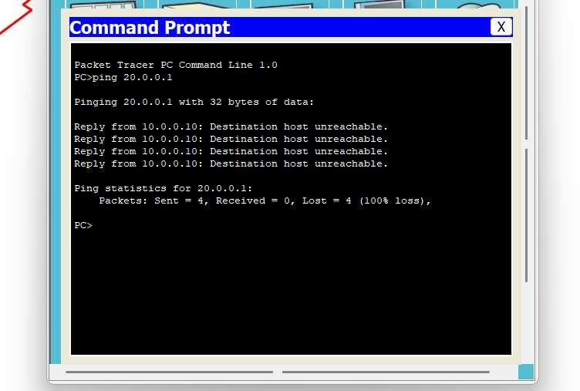

**Program 3**

Aim : Configure IP address to routers in packet tracer. Explore the following messages: ping responses, destination unreachable, request timed out, reply

Observation:

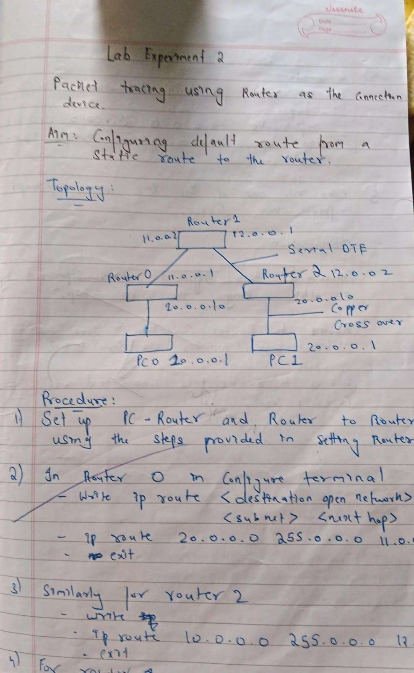

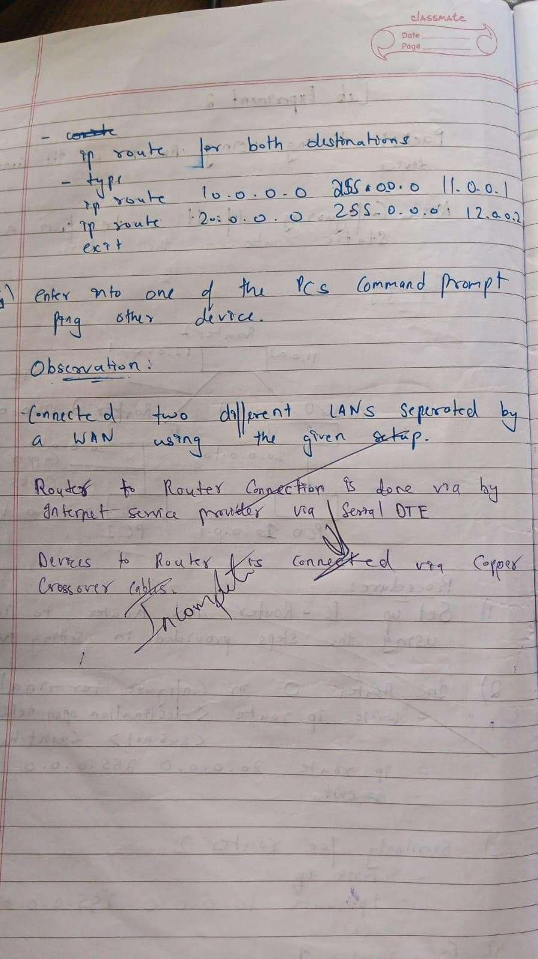

Output:

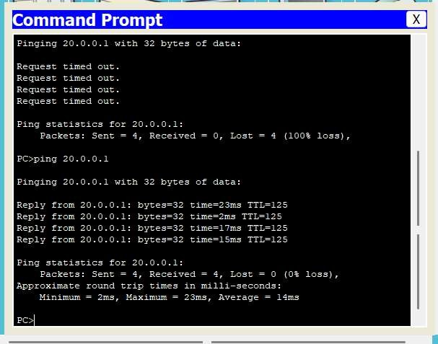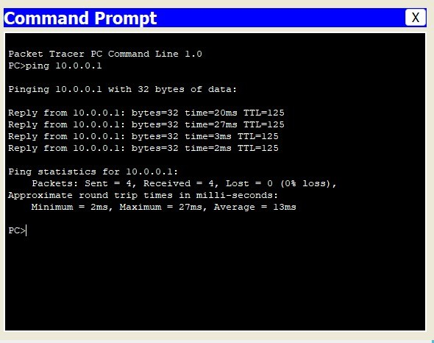

**Program 4**

Aim : Configure DHCP within a LAN and outside LAN. Observation:

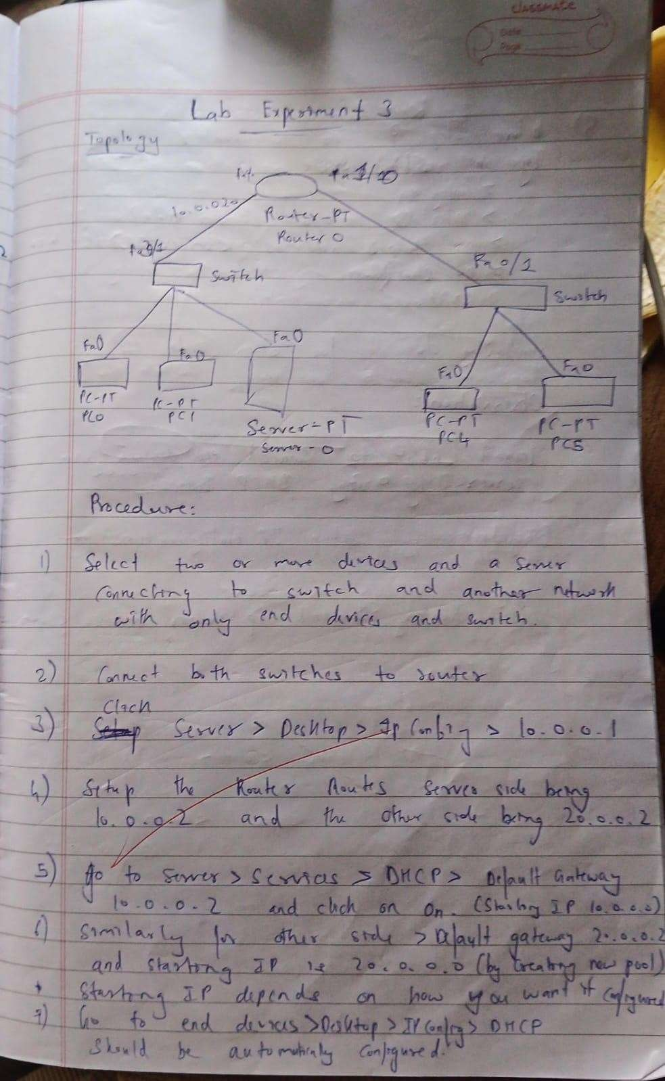

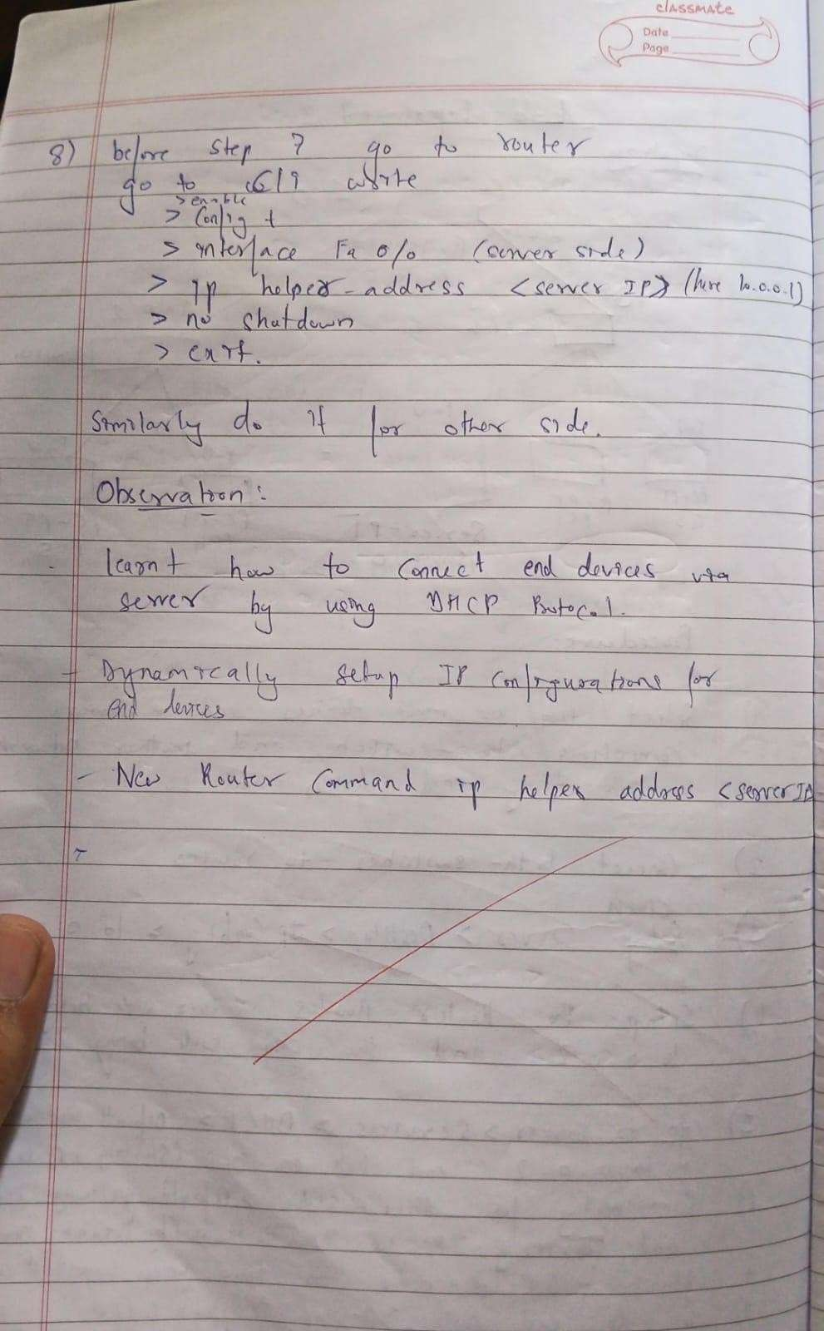

Output:

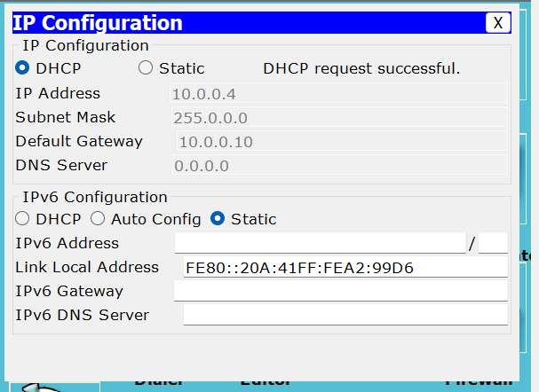

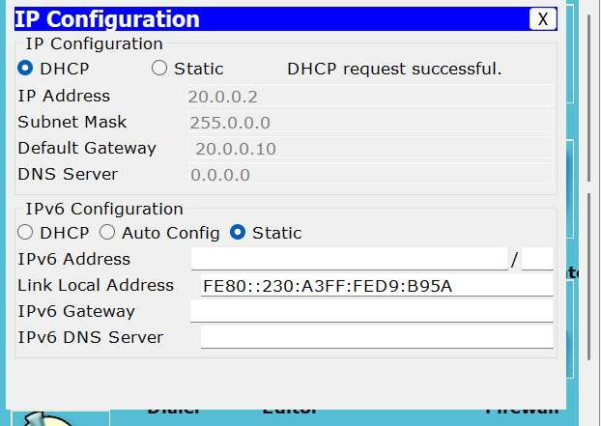

**Program 5**

Aim : Configure RIP routing Protocol in Routers Observations :

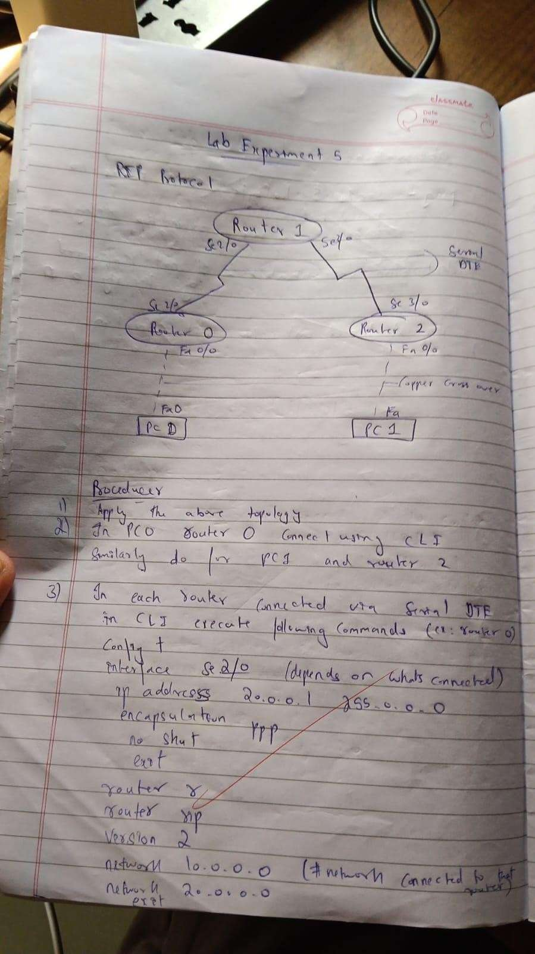

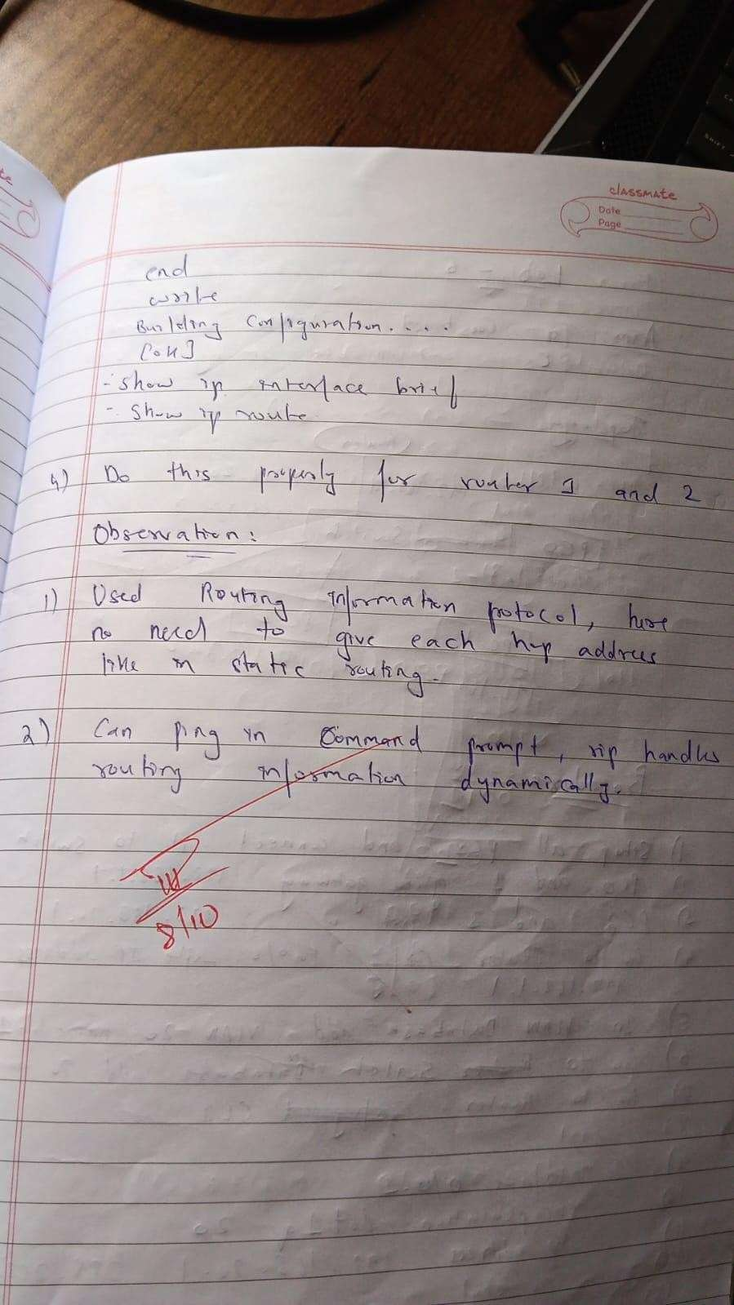

Output:

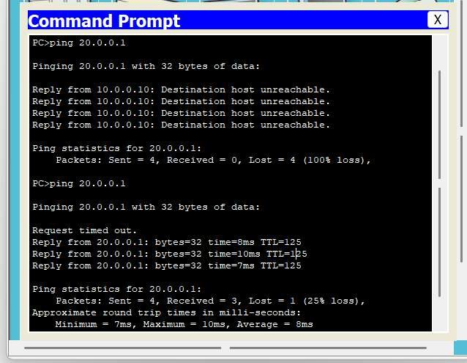

**Program 6**

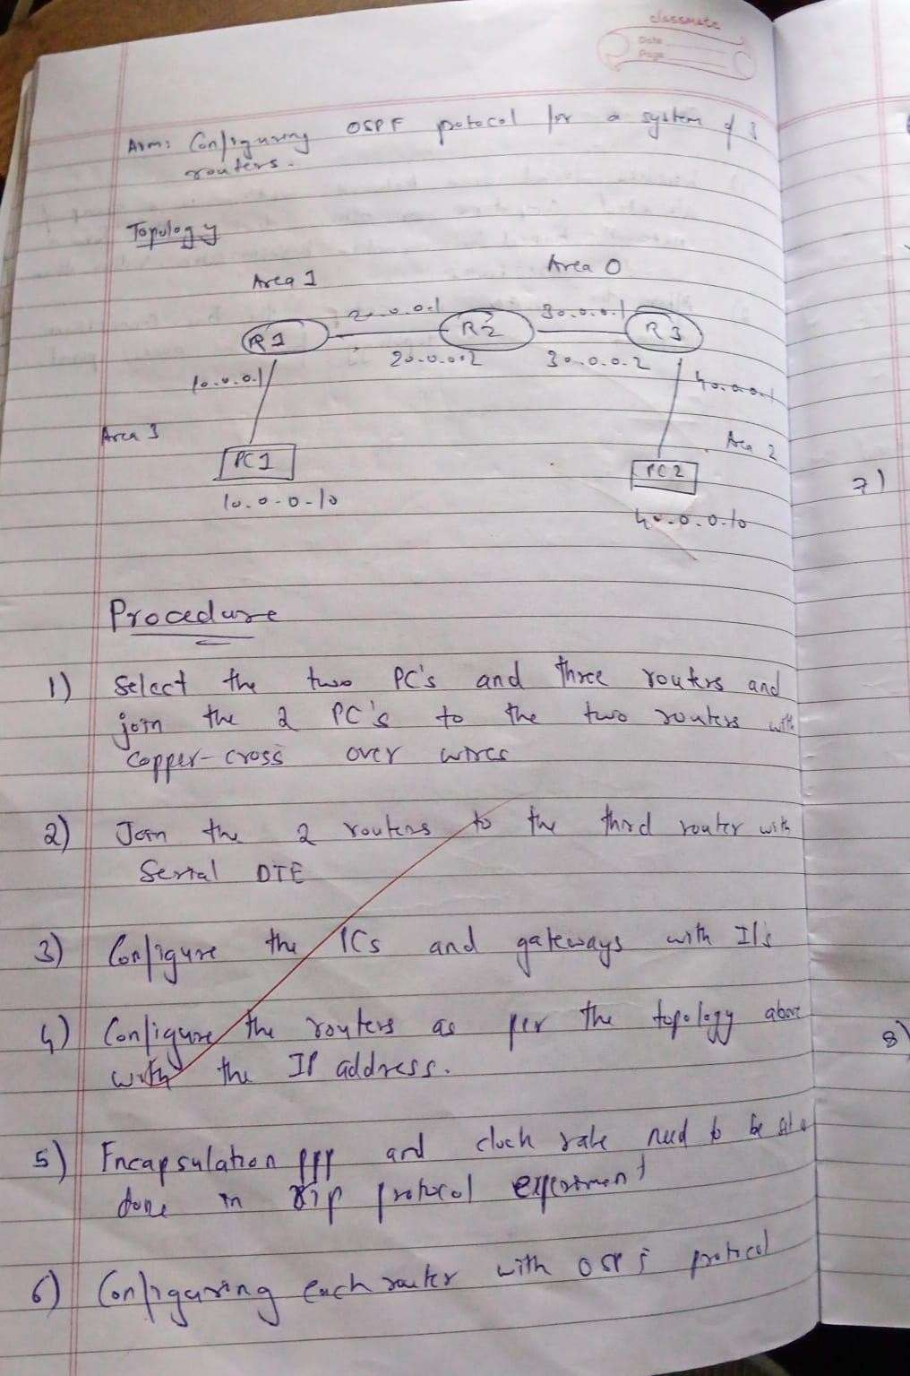Aim : Configure OSPF routing Protocol Observations:

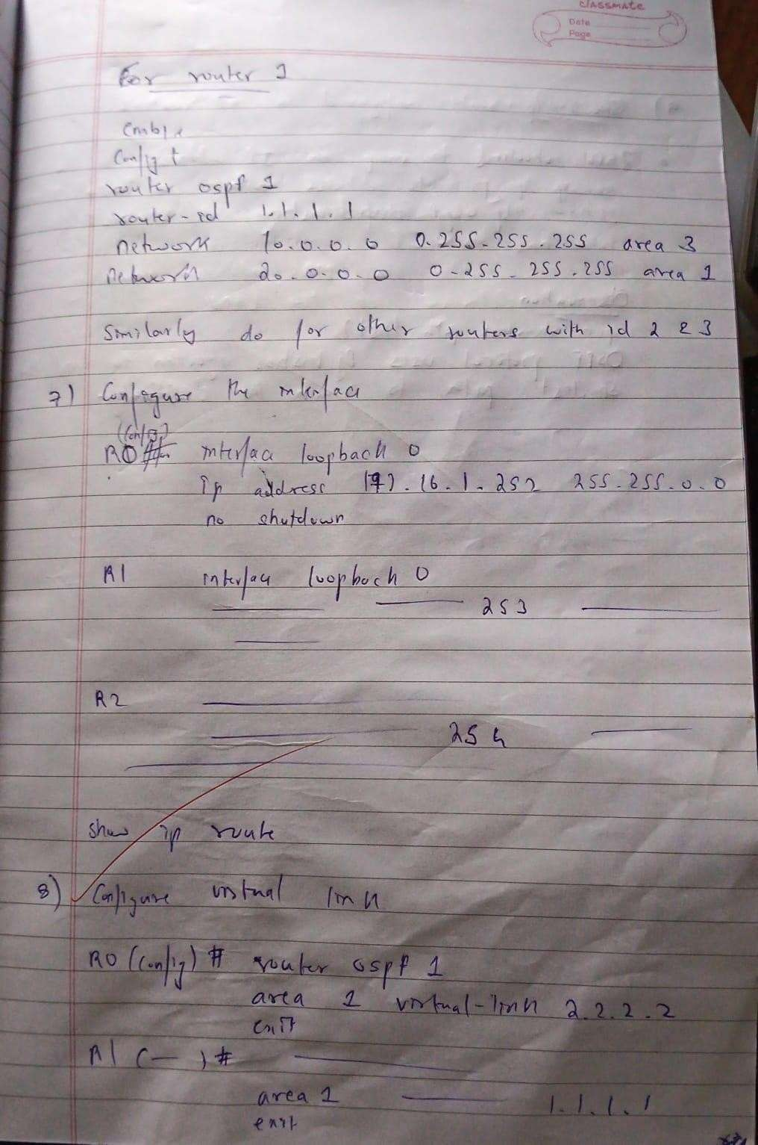

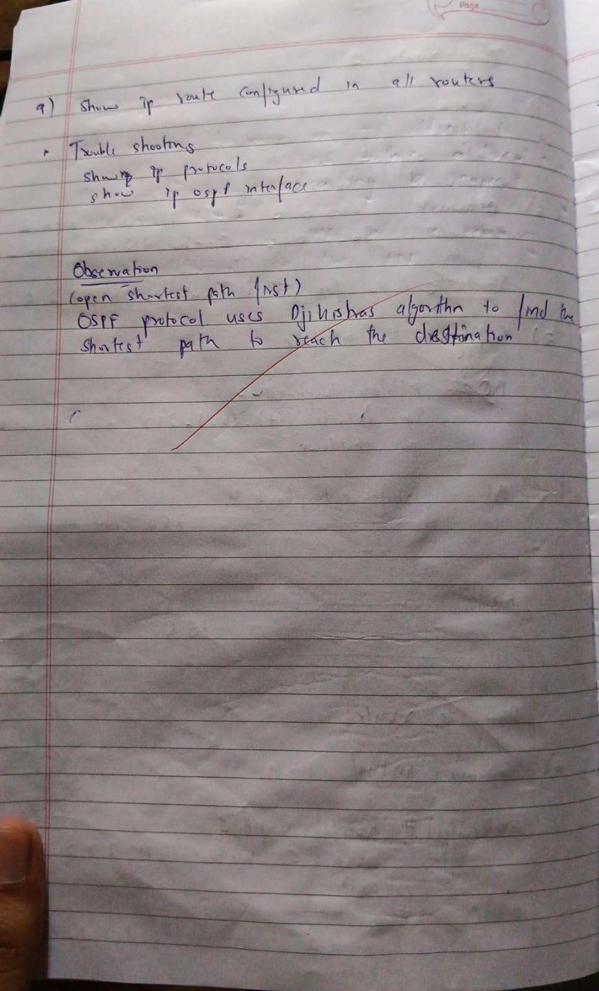

Output:

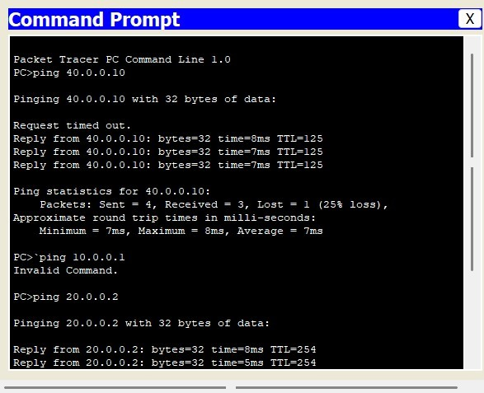

**Program 7**

Aim : Demonstrate the TTL/ Life of a Packet Observations:

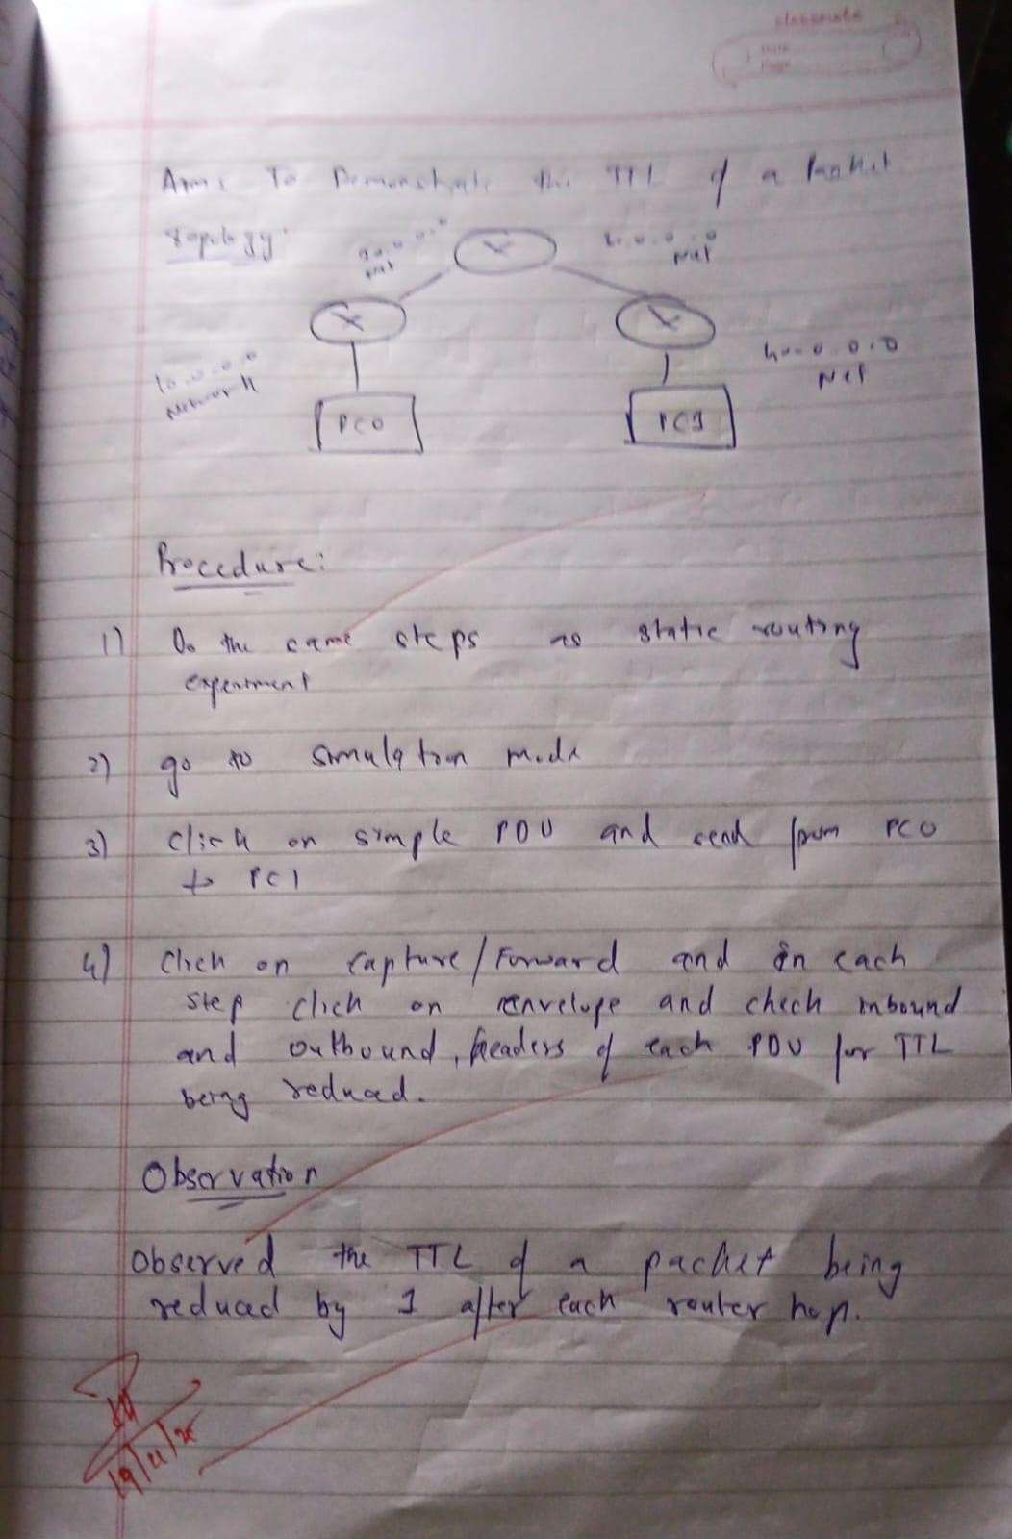

Output:

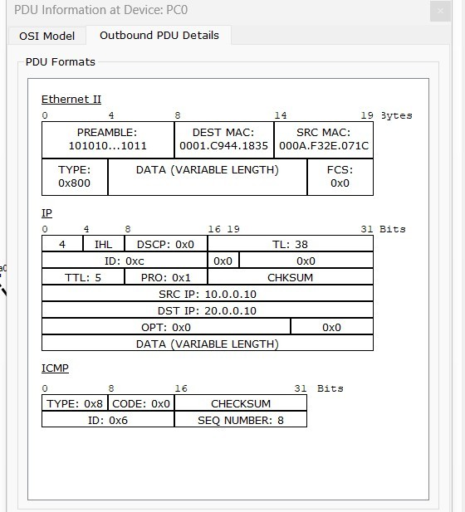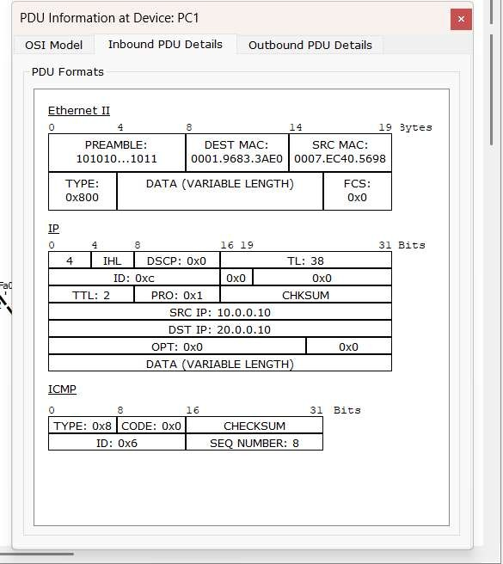

**Program 8**

Aim : Configure Web Server, DNS within a LAN. Observation:

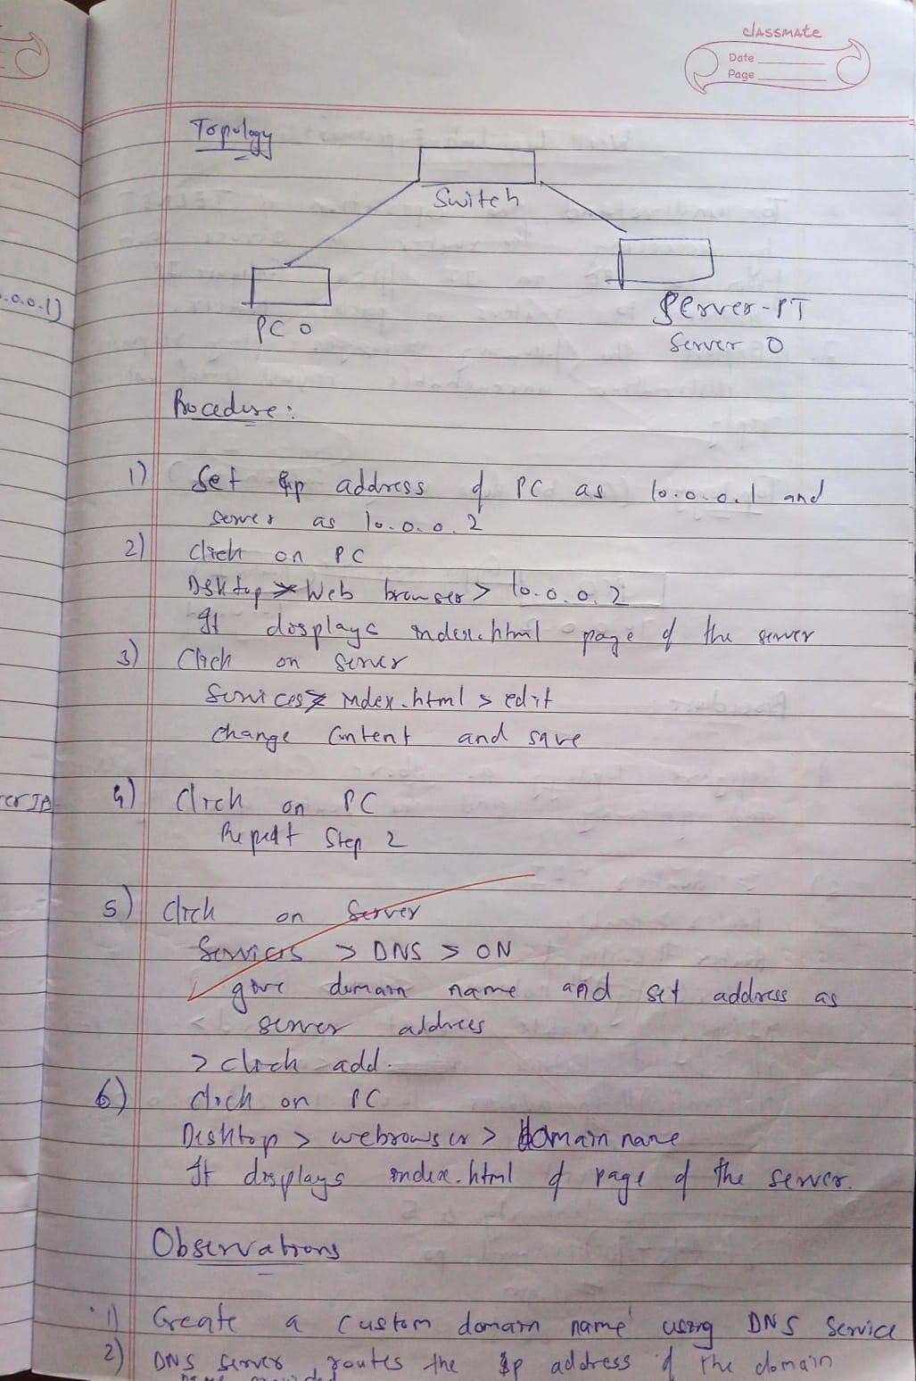

Output:

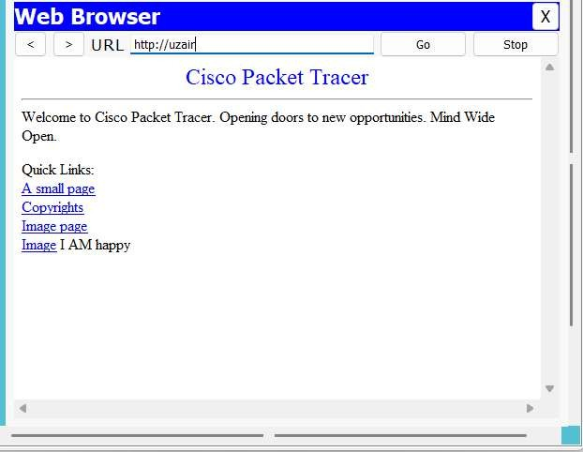

**Program 9**

Aim : To construct simple LAN and understand the concept and operation of Address Resolution Protocol (ARP)

Observation:

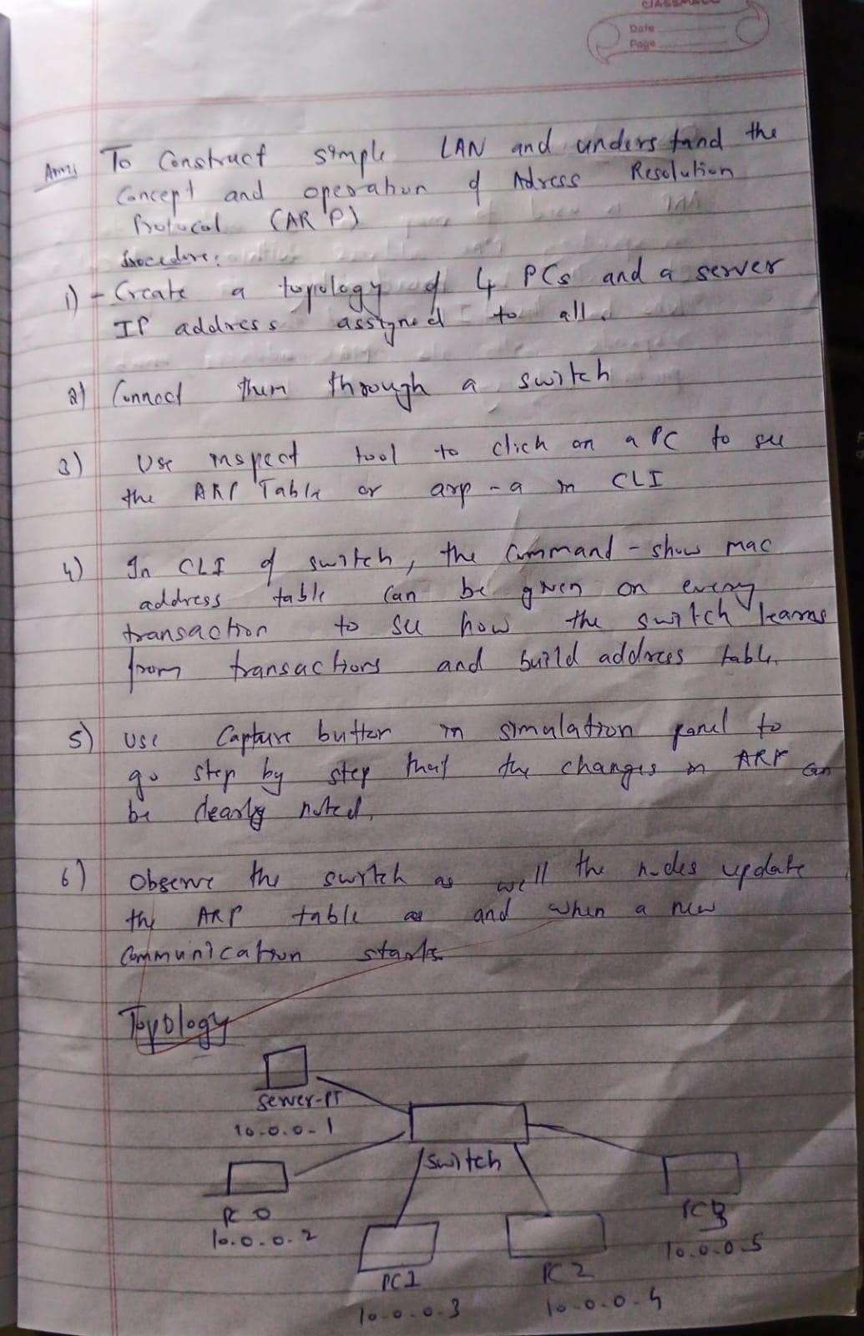

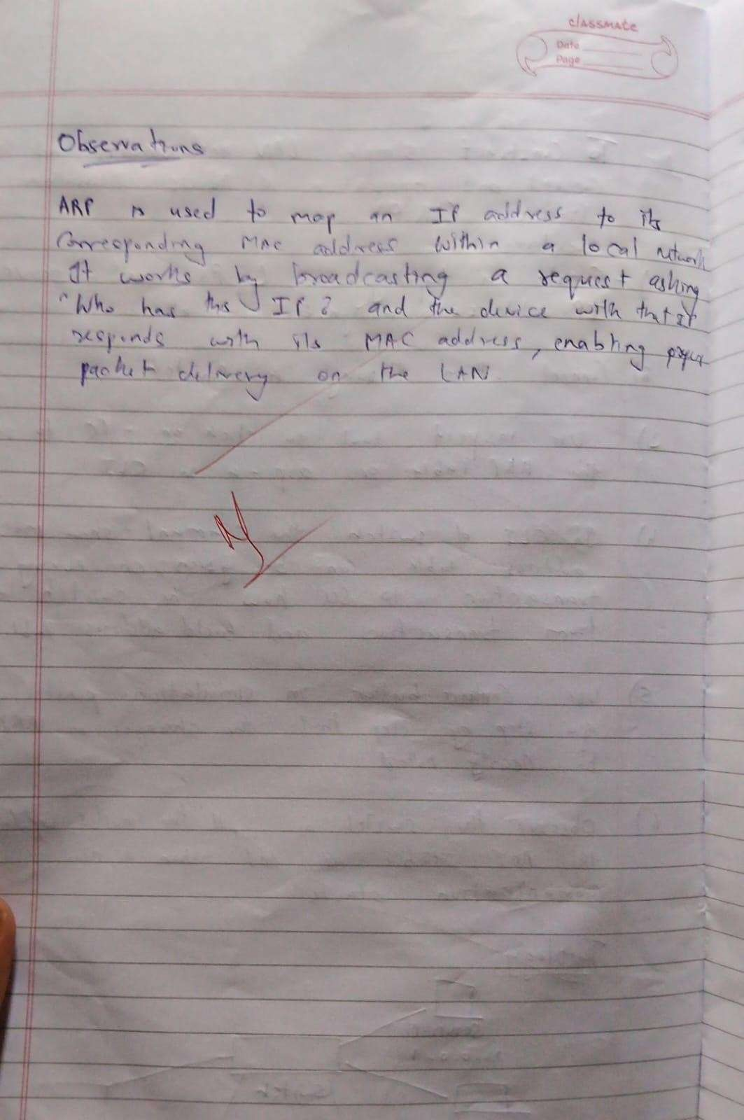

Output:

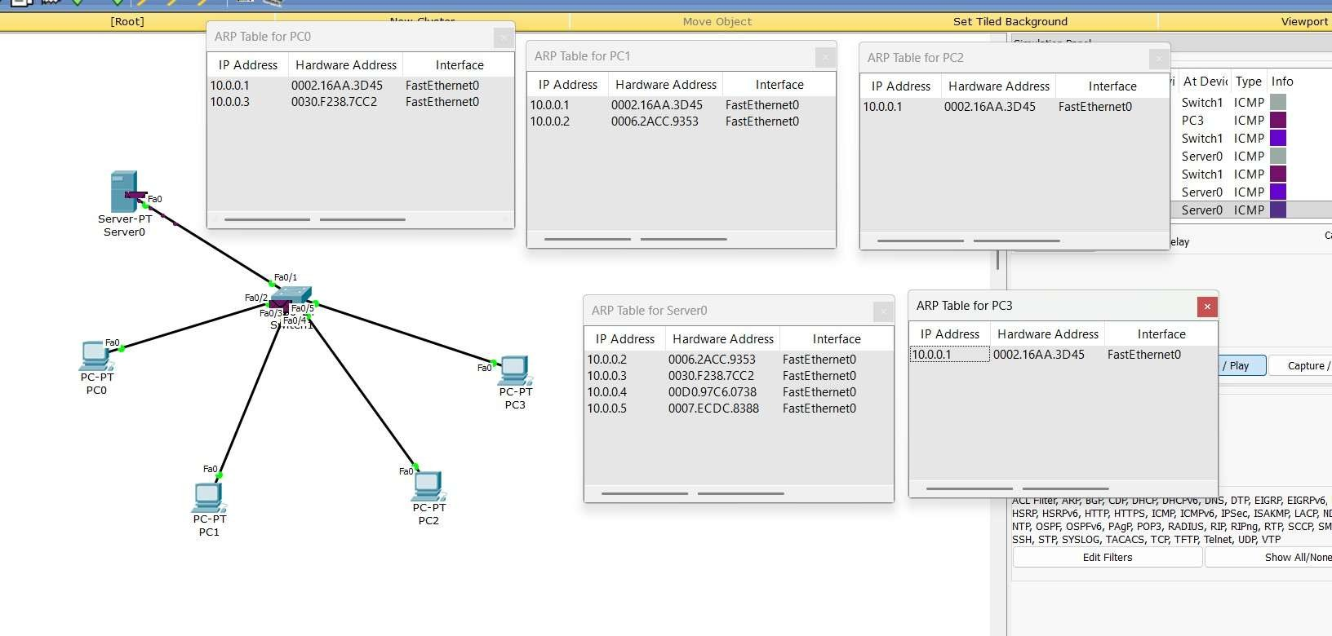

**Program 10**

Aim : To understand the operation of TELNET by accessing the router in server room from a PC in IT office.

Observation:





Output:



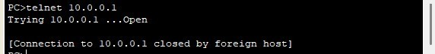

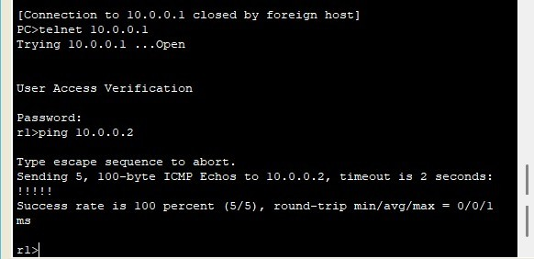

**Program 11**

Aim : To construct a VLAN and make the PC’s communicate among a VLAN

Observation:

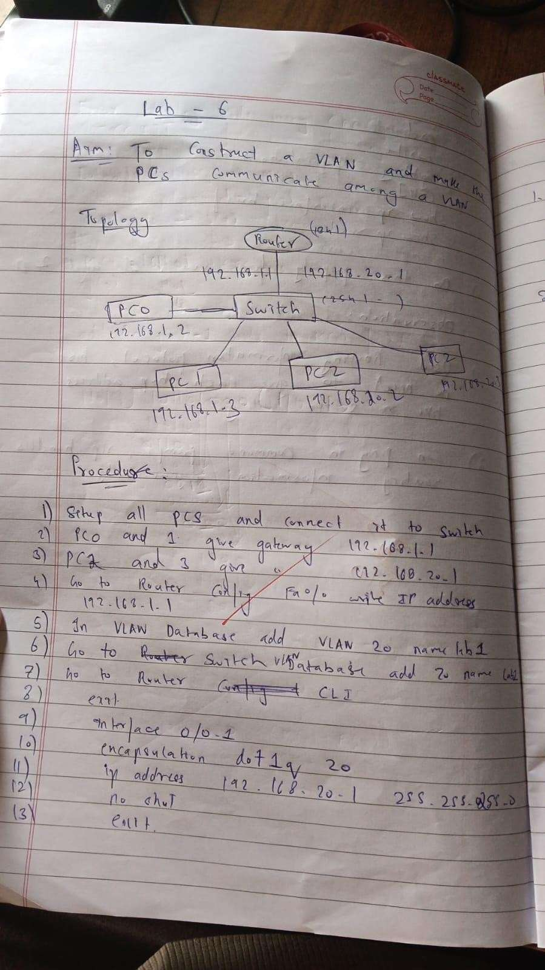

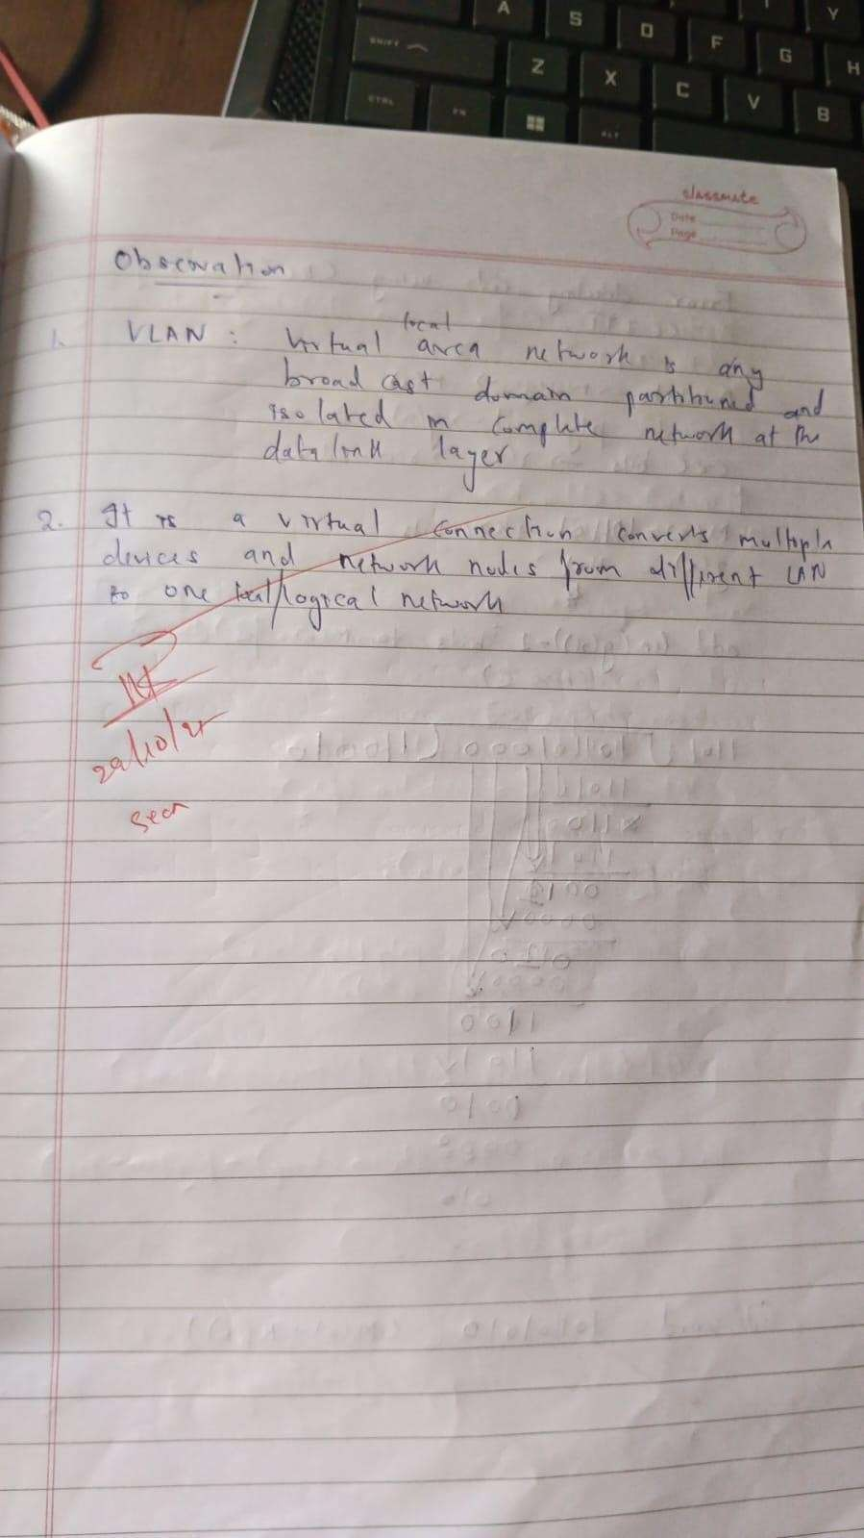

Output:

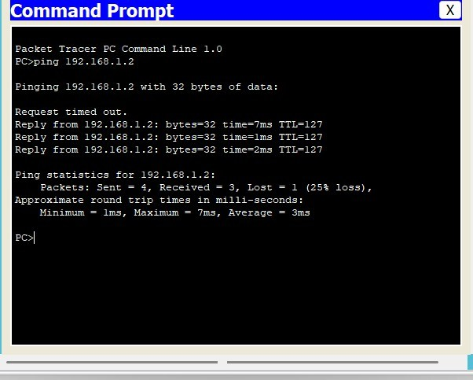

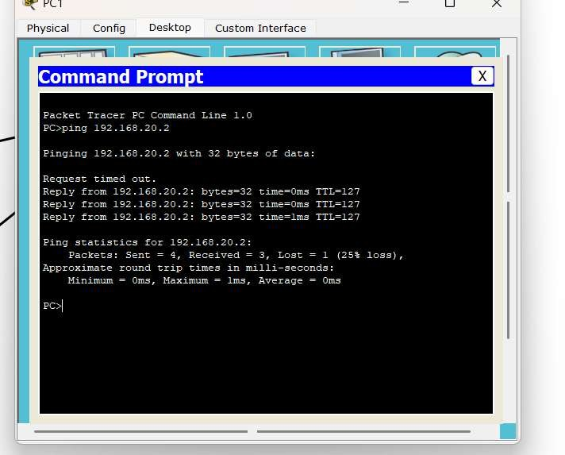

**Program 12**

Aim : To construct a WLAN and make the nodes communicate wirelessly

Observation:

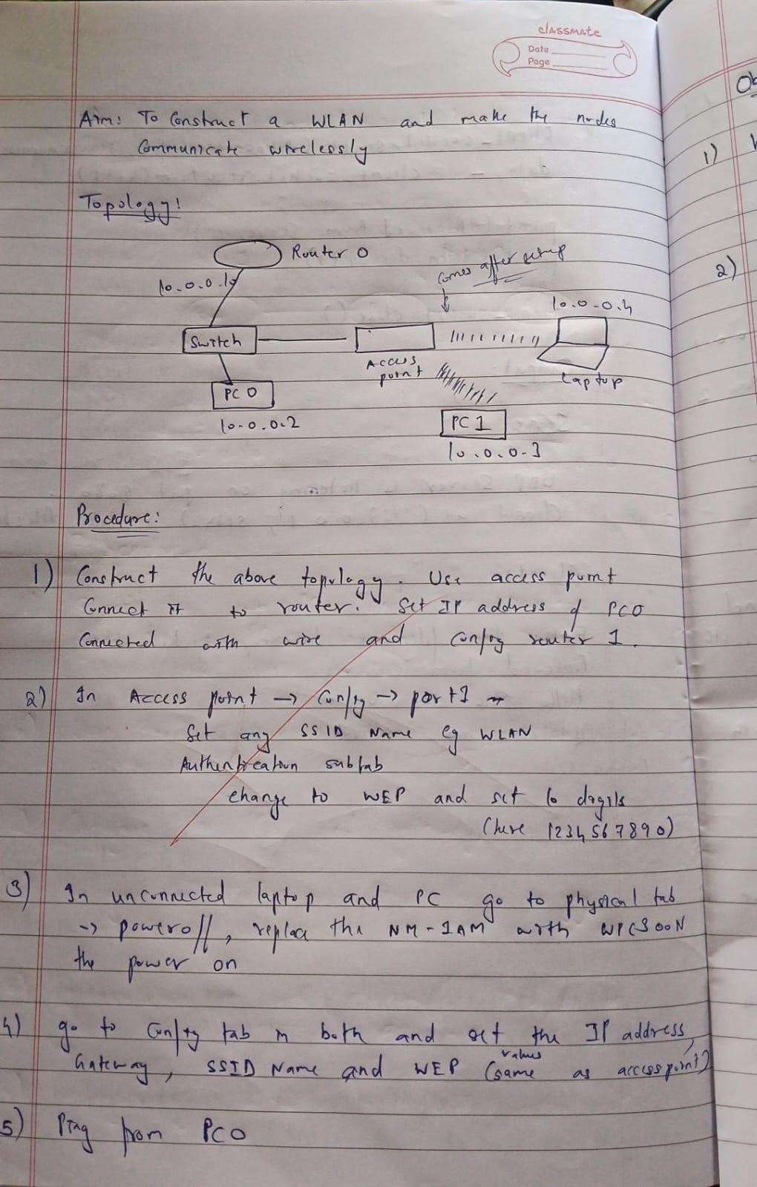

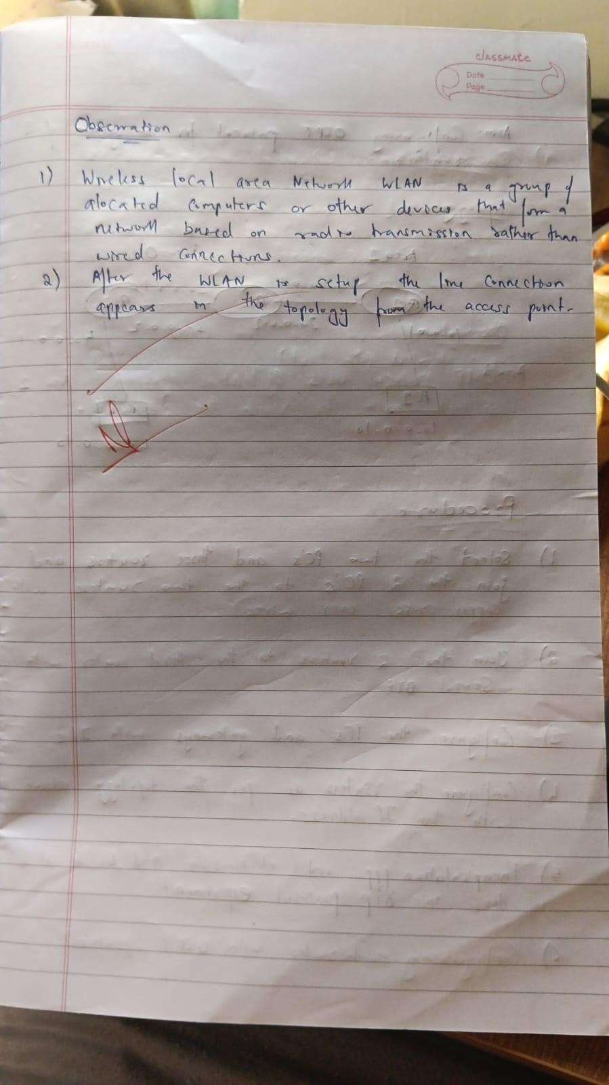

Output:

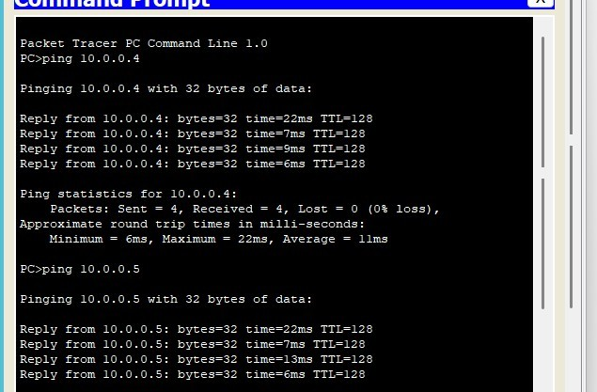

**Program 13**

Aim : Write a program for error detecting code using CRC-CCITT (16-bits).

Observation:

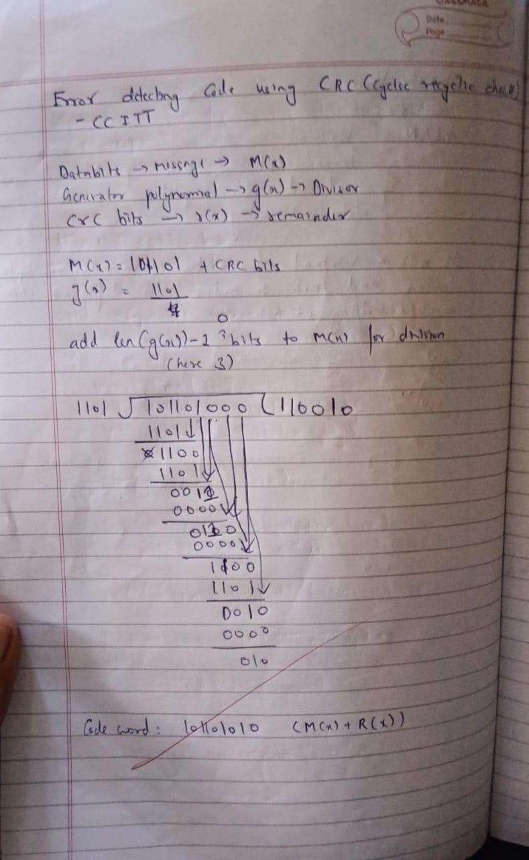

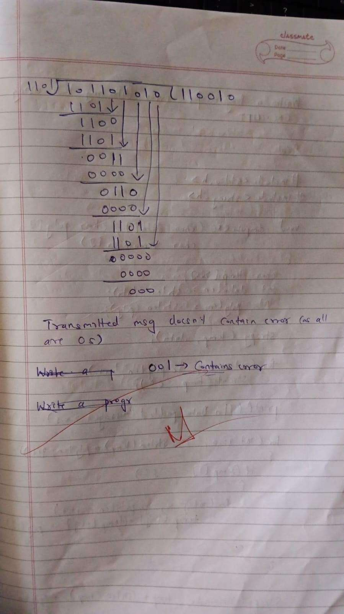

Code:

#include <stdio.h> #include <string.h>

void computeCRC(char data[], char poly[], char remainder[])

{

char temp[200];

int dataLen = strlen(data); int polyLen = strlen(poly);

strcpy(temp, data);

// Append (polyLen - 1) zeros to data for (int i = 1; i < polyLen; i++)

strcat(temp, "0");

printf("\nData padded (message + zeros): %s\n", temp);

// Perform binary division

for (int i = 0; i <= strlen(temp) - polyLen; i++)

{

if (temp[i] == '1')

{

for (int j = 0; j < polyLen; j++)

temp[i + j] = (temp[i + j] == poly[j]) ? '0' : '1';

}

}

// CRC = last (polyLen-1) bits

strcpy(remainder, temp + (strlen(temp) - (polyLen - 1)));

}

int checkReceived(char received[], char poly[])

{

char temp[200];

int polyLen = strlen(poly); strcpy(temp, received);

// Perform division on received message

for (int i = 0; i <= strlen(temp) - polyLen; i++)

{

if (temp[i] == '1')

{

for (int j = 0; j < polyLen; j++)

temp[i + j] = (temp[i + j] == poly[j]) ? '0' : '1';

}

}

// Check any '1' in remainder portion

for (int i = strlen(temp) - (polyLen - 1); i < strlen(temp); i++) if (temp[i] == '1')

return 0; // Error detected

return 1; // No error

}

int main()

{

char message[100], poly[30], crc[30], transmitted[150], received[150];

printf("Enter the message bits : "); scanf("%s", message);

printf("Enter the polynomial (g(x)) : "); scanf("%s", poly);

computeCRC(message, poly, crc);

printf("CRC value (remainder) : %s\n", crc);

// Form transmitted message strcpy(transmitted, message); strcat(transmitted, crc);

printf("Message to be transmitted : %s\n", transmitted);

// Receiver side

printf("\nEnter received message bits (can modify 1 bit to test error): "); scanf("%s", received);

if (checkReceived(received, poly))

printf("\ n⬛No Error: Message received correctly.\n"); else

printf("\n+ ERROR detected in received message!\n");

return 0;

}

Output:

Enter the message bits 101101 Enter the polynomial (g(x)) : 1101

Data padded (message + zeros): 101101000 CRC value (remainder) 101

Message to be transmitted 101101101

Enter received message bits (can modify 1 bit to test error): 101101101

* No Error: Message received correctly.

**Program 14**

Aim : Write a program for congestion control using Leaky bucket algorithm.

Observation:

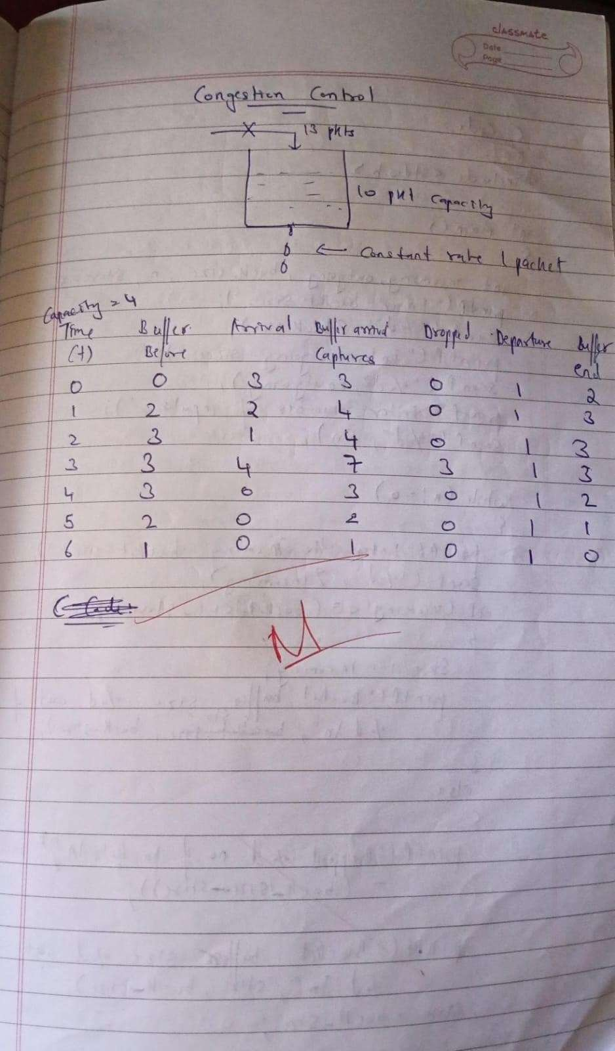

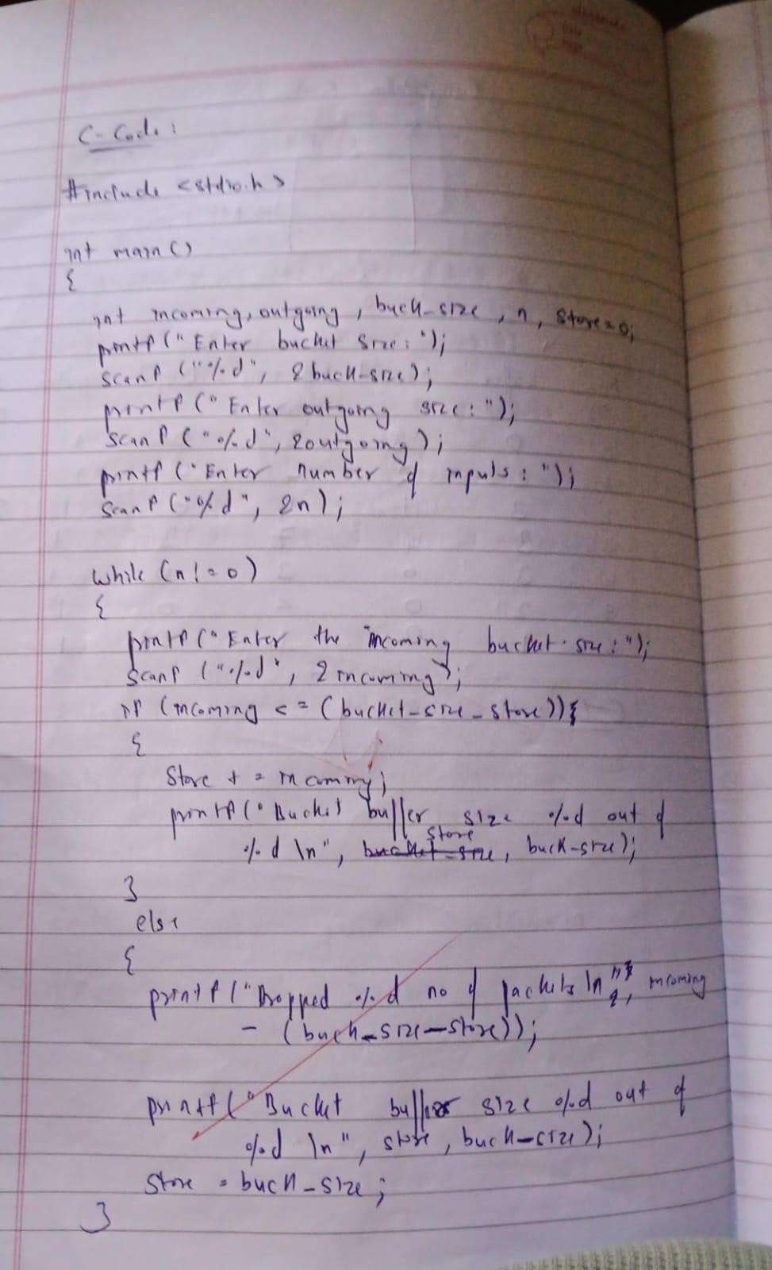

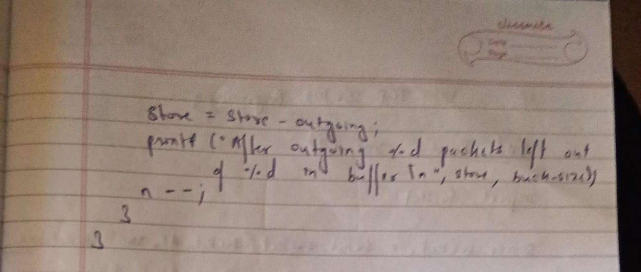

Output:

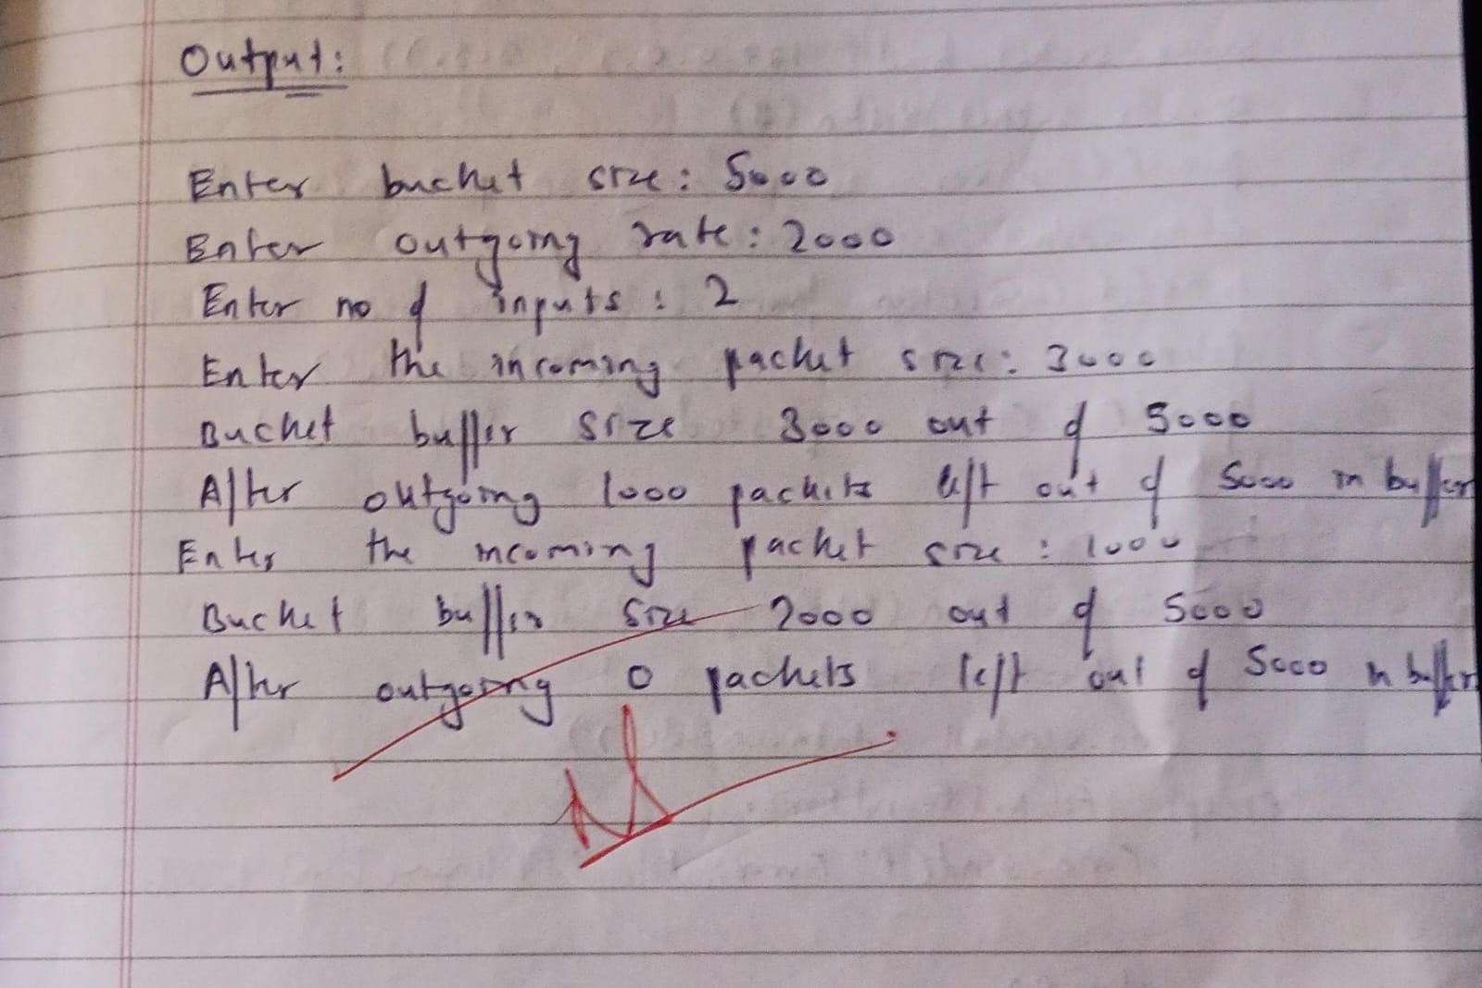

**Program 15**

Aim: Using TCP/IP sockets, write a client-server program to make client sending the file name and the server to send back the contents of the requested file if present.

Observation:

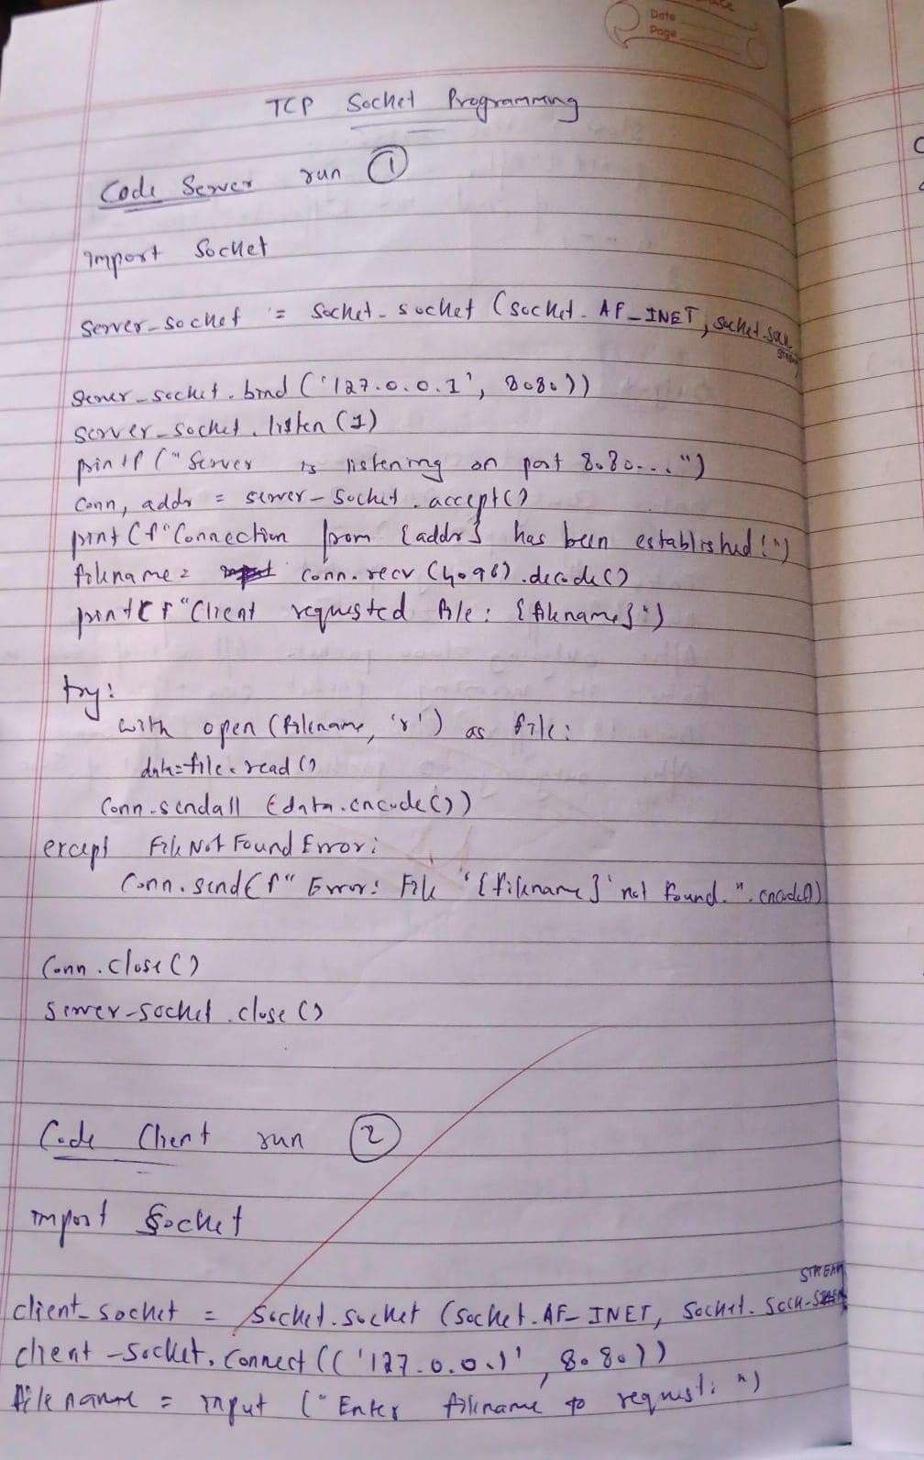

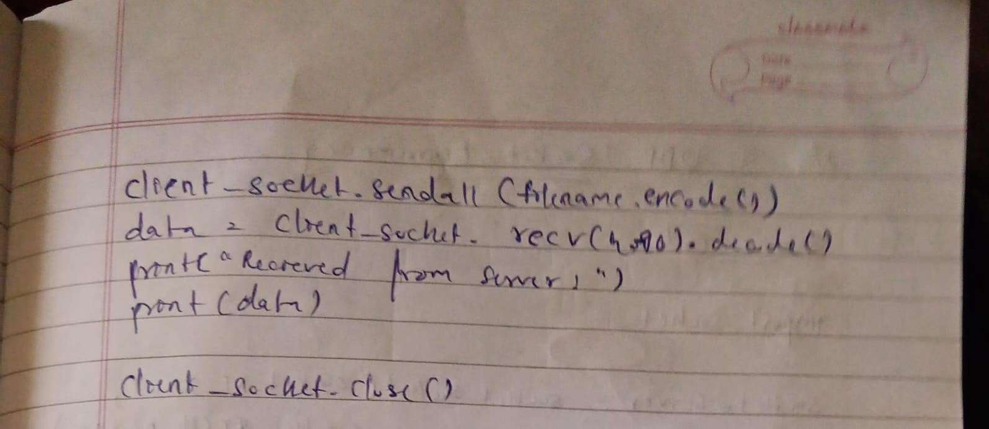

Output:

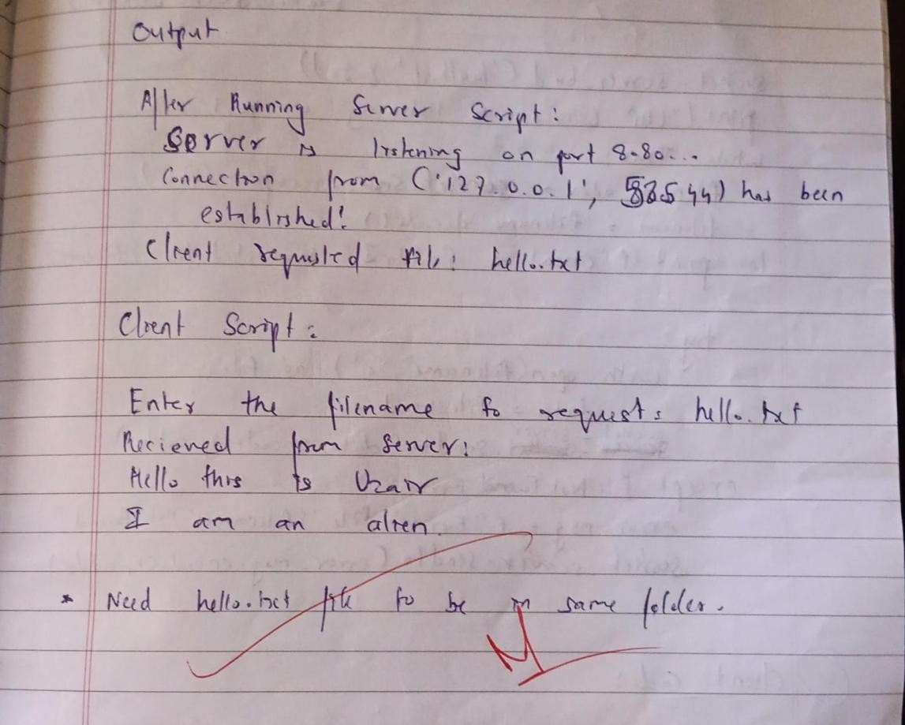

**Program 15**

Aim: Using UDP sockets, write a client-server program to make client sending the file name and the server to send back the contents of the requested file if present.

Observation:

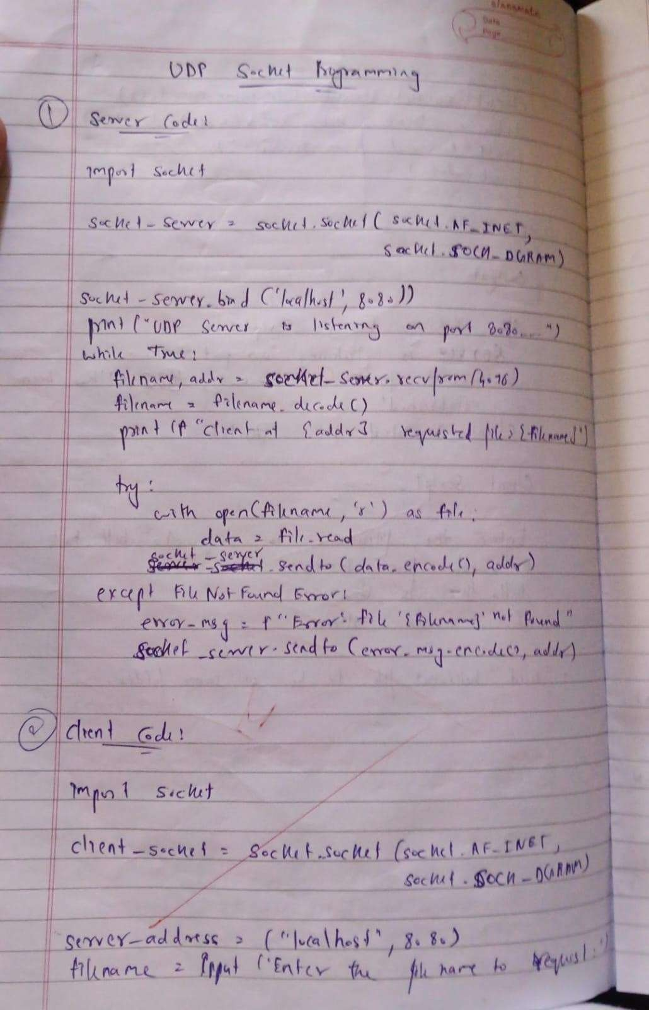

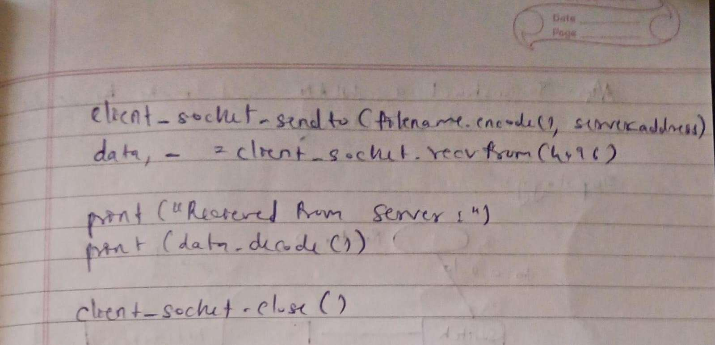

Output:

